**ASSIGNMENT NO. 7**

**AIM :-** Write X86 program to sort the list of integers in ascending/descending order. Read the input from the text file and write the sorted data back to the same text file using bubble sort

**APPARATUS :**

* Core 2 duo/i3/i5/i7 - 64bit processor
* OS – ubuntu 32bit/64bit OS
* Assembler used –nasm (the netwide assembler)
* Editor Used – gedit

**THEORY :**

**Bubble Sort:**

The bubble sort makes multiple passes through a list. It compares adjacent items and exchanges those that are out of order. Each pass through the list places the next largest value in its proper place. In essence, each item “bubbles” up to the location where it belongs.

Figure shows the first pass of a bubble sort. The shaded items are being compared to see if they are out of order. If there are n items in the list, then there are n−1 pairs of items that need to be compared on the first pass. It is important to note that once the largest value in the list is part of a pair, it will continually be moved along until the pass is complete.

At the start of the second pass, the largest value is now in place. There are n−1 items left to sort, meaning that there will be n−2 pairs. Since each pass places the next largest value in place, the total number of passes necessary will be n−1. After completing the n−1 passes, the smallest item must be in the correct position with no further processing required.

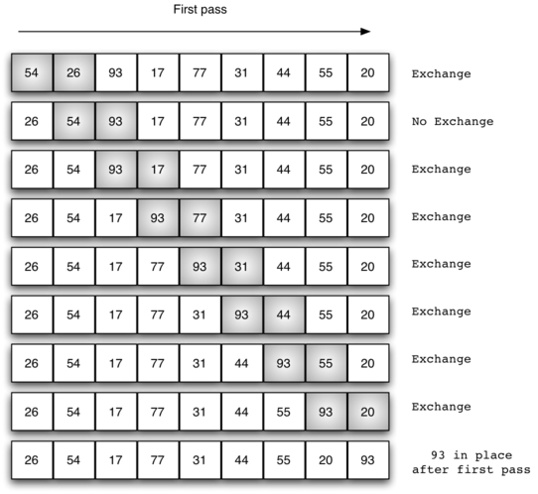

**Algortihm**

function bsort(array)

{

for (RCX = 0 to RBP - 1)

{

for (RBX = 0 to RBP - i)

{

if ([RSI] > [RDI])

{

swap(a[j], a[j+1]);

}

}

}

}

**CONCLUSION:**

______________________________________________________________________________________________________________________________________________________________________________________________________________________________